

Climograph Investigation

SUBJECT: Climate, graphing, weather variables, and geography.

GRADE LEVEL: 9th – 12th

DEPTH OF KNOWLEDGE LEVEL: 2 and 3

AUTHOR: Dr. Lawrence Rudd, School of Education, Nevada State College, Lawrence.rudd@nsc.edu

NEXT GENERATION SCIENCE STANDARDS:

1. Change and rates of change can be quantified and modeled over very short or very long periods of time. Some system changes are irreversible. (HS-ESS3-5)
2. Design or refine a solution to a complex real-world problem, based on scientific knowledge, student-generated sources of evidence, prioritized criteria, and tradeoff considerations. (HS-ESS3-4)
3. Science knowledge is based on empirical evidence. (HS-ESS3-5)
4. Integrate and evaluate multiple sources of information presented in diverse formats and media (e.g., quantitative data, video, multimedia) in order to address a question or solve a problem. (HS-ESS3-5)

PRIOR KNOWLEDGE: Students will know how to draw and interpret graphs. Students will be familiar with weather variables and have a working definition of climate.

INTRODUCTORY ACTIVITY: Carefully examine the world climate map at: [http://koeppen-geiger.vu-wien.ac.at/present.htm](http://www.google.com/url?q=http://koeppen-geiger.vu-wien.ac.at/present.htm&ei=JzHXUZWoJKOKiALiiYC4DQ&sa=X&oi=unauthorizedredirect&ct=targetlink&ust=1373059119597613&usg=AFQjCNGPtXow_Vu2mRZ5OEVudav5qTTXFQ). What weather variables are described by the three-letter combinations shown in the key to the colors used on the map?

1. Find the approximate location of where you live on this map. Does the three-letter combination used to describe the climate at this location closely match the temperature and precipitation that you experience throughout the year?

CONCEPT/SKILL DEVELOPMENT:

**Objective:**

The purpose of this investigation is to be able to read and interpret a climograph.

**Materials:**

Climographs of each transect measurement station.

**Important Terms:**

Climograph

Climate

**Diving question:**

What essential information does a climograph display and how can this information be used to better understand climate?

**Background Information**

Data from the transect measurement stations has been collected since the spring of 2011. Climographs are usually made using data that has been collected over a long time period (30 or more years). This discrepancy results in the climographs based on transect data exhibiting more variability than would be expected, especially in the precipitation curves. These graphs were made in 2013 based on two years of data from each of the transect data stations. As more years of data are gathered the extent to which these graphs represent the true climate at each data collection site will improve. Part B of this investigation involves comparing this set of graphs to a second set of graphs created from data from 1980 to 2012.

While you are working on the introductory activity, visit the site:

<http://sensor.nevada.edu/NCCP/Climate%20Monitoring/Equipment.aspx>

to examine both the instrumentation at each site as well as the data transect locations.

**Resources**

<http://www.weather.com/encyclopedia/>

Descriptions of a variety of storms and weather phenomena in an encyclopedic format.

<http://www.exploringweather.com/index.html>

A site that focuses on storms, as well as the process of weather forecasting. This site also includes a useful glossary of weather terms.

<http://sensor.nevada.edu/NCCP/Default.aspx>

The Nevada Climate Change Portal. This site explains the Nevada Climate Change project.

<http://daymet.ornl.gov/custom_home>

This site gives access to a model that provides weather data for North America from 1980 to 2011. The Daymet model was used to create the long-term climographs (Figures 8-14) used in this investigation. Click on Daily Data for a Single Pixel in the left-hand column to get weather data for any location in North America.

<http://www.nws.noaa.gov/om/coop/what-is-coop.html>

A description of the National Weather Service’s Cooperative Observer Program (COOP). This description also includes an interesting history of the program. Links to various COOP sites throughout the country are also included. COOP data was used to make the climograph of the Desert Game Range, figure 15.

<http://www.raws.dri.edu/documents/RAWS.pdf>

Fact sheet describing the RAWS program and the instrumentation on each of the RAWS weather stations.

<http://www.raws.dri.edu/wraws/nvutF.html>

Interactive map showing all of the Remote Automated Weather Station (RAWS) sites in Nevada, Utah, and parts of Arizona and California.

**Investigation (Part 1):**

1. Examine the climographs in figures 1-7. What information on the graphs indicates that all of the stations are in the northern hemisphere? Explain.
2. Are there any trends to the temperature data? If so, describe the trends.
3. Are there any trends to the precipitation data? If so, describe the trends.
4. Identify a part on one of the graphs that probably does not provide a true representation of the climate at the site. Describe your choice and explain why you believe it is a problem.
5. Examine a map of world climates. Use the legend on the map to give each of the transect measurement stations a three-letter climatic description.
6. Explain your choice of the three letters to describe the transect station’s climate.

**Investigation (Part 2):**

1. Examine the climographs in figures 8-14. Compare each climograph to the climograph of the same transect site in figures 1-7. Pick three pairs of climographs and describe two similarities and two differences between the pairs of graphs.
2. Why do you think that the differences that you described in question 1 exist?
3. Name three advantages of collecting data over a minimum of thirty years to accurately describe climate.

**Investigation (Part 3):**

1. Examine the climograph in figure 15. This data in this climograph was collected over a period of 65 years at a weather station located about ½ kilometer from the Sheep Range Desert Shrub Transect Station. Compare the climograph in figure 15 to the climographs in figures 1 and 8. Describe at least two similarities and two differences between these three graphs.
2. Why do you think that the differences that you described in question 1 exist?
3. Describe two conclusions that you can make from these three graphs regarding how the climate has changed in this area over the past 65 years.

**Extension**

Return to the world climate map at: [http://koeppen-geiger.vu-wien.ac.at/present.htm](http://www.google.com/url?q=http://koeppen-geiger.vu-wien.ac.at/present.htm&ei=JzHXUZWoJKOKiALiiYC4DQ&sa=X&oi=unauthorizedredirect&ct=targetlink&ust=1373059119597613&usg=AFQjCNGPtXow_Vu2mRZ5OEVudav5qTTXFQ). Find one location on each of the seven continents and describe the climate at that location using the three-letter combination from the colors on the map. Briefly write down what this tells you about each location you chose and sketch a climograph for each of your locations.

CLOSING ACTIVITY:

Have students should work in groups to complete the third investigation. Use the discussions that take place in each group as the basis for a whole-class discussion of the nature of climate and how climates in different locations have changed through time and are changing today.

**References**

Thornton, P.E., H. Hasenauer, and M.A. White. 2000. Simultaneous estimation of daily solar radiation

and humidity from observed temperature and precipitation: An application over complex terrain in Austria. Agricultural and Forest Meteorology 104:255-271.

Thornton, P.E. and S.W. Running. 1999. An improved algorithm for estimating incident daily solar

radiation from measurements of temperature, humidity, and precipitation. Agriculture and Forest Meteorology. 93:211-228.

Thornton, PE, MM Thornton, BW Mayer, N Wilhelmi, Y Wei, RB Cook. 2012. Daymet: Daily surface

weather on a 1 km grid for North America,1980 - 2012. Acquired online (<http://daymet.ornl.gov/>) on [insert acquisition date here: DD/MM/YYYY] from Oak Ridge National Laboratory Distributed Active Archive Center, Oak Ridge, Tennessee, U.S.A. doi:10.3334/ORNLDAAC/Daymet_V2.

**Figures 1-7.** Climographs based on data from the Nevada Climate-ecohydrology Assessment Network (<http://sensor.nevada.edu/NCCP/Climate%20Monitoring/Network.aspx>) transects in the Sheep and Snake Ranges.

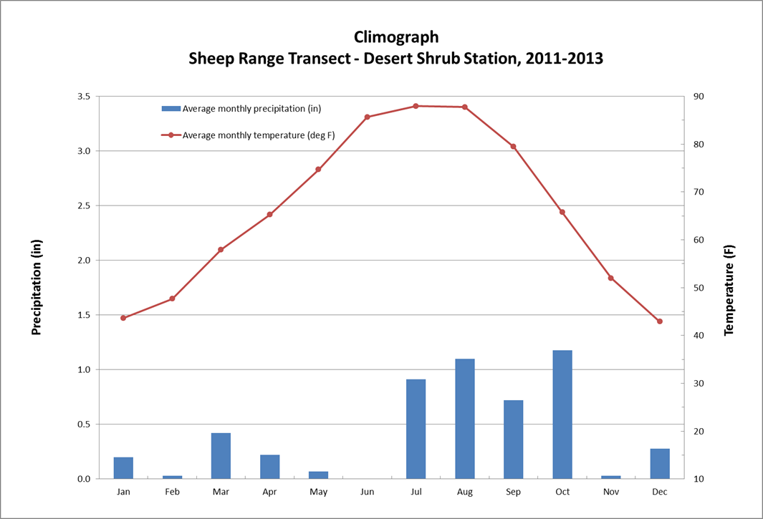

**Figure 1.**

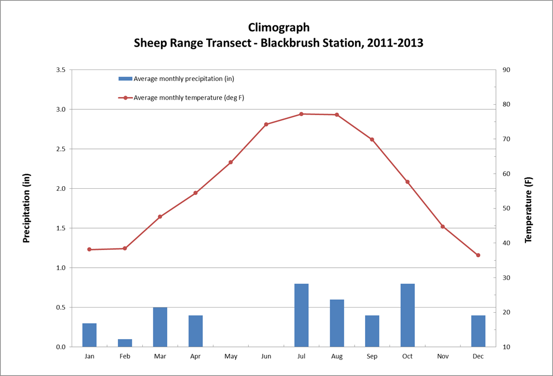

**Figure 2.**

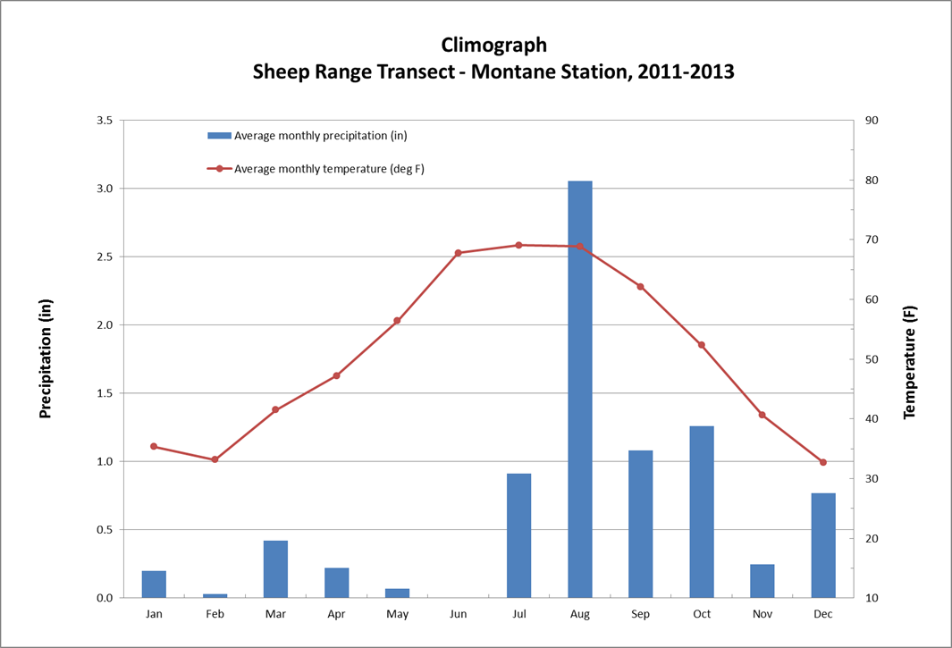

**Figure 3.**

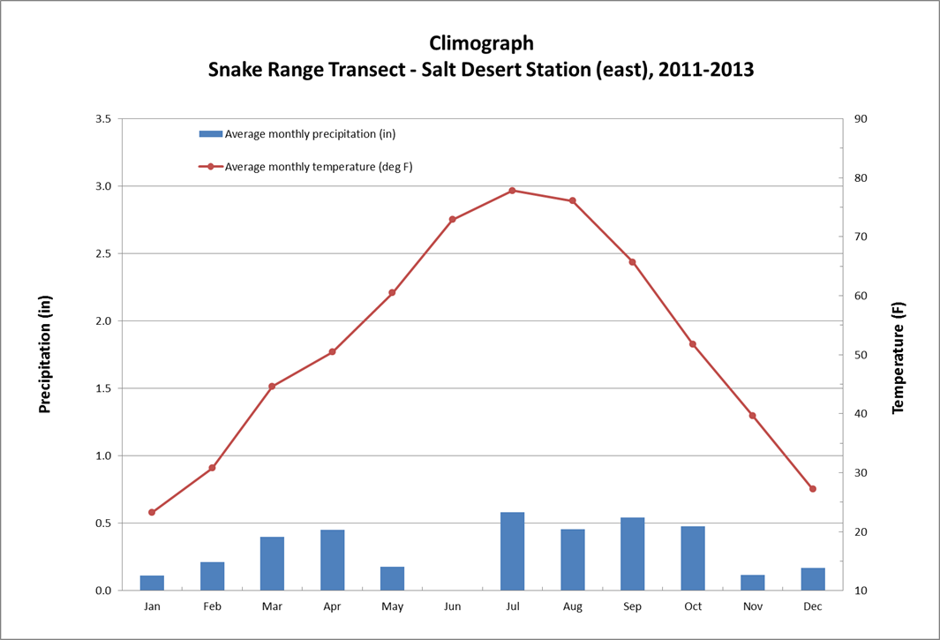

**Figure 4.**

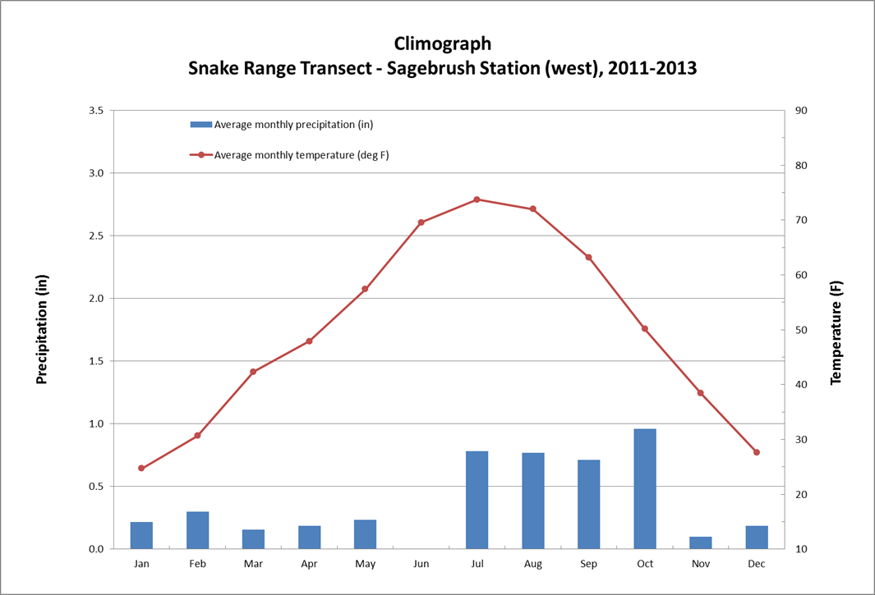

**Figure 5.**

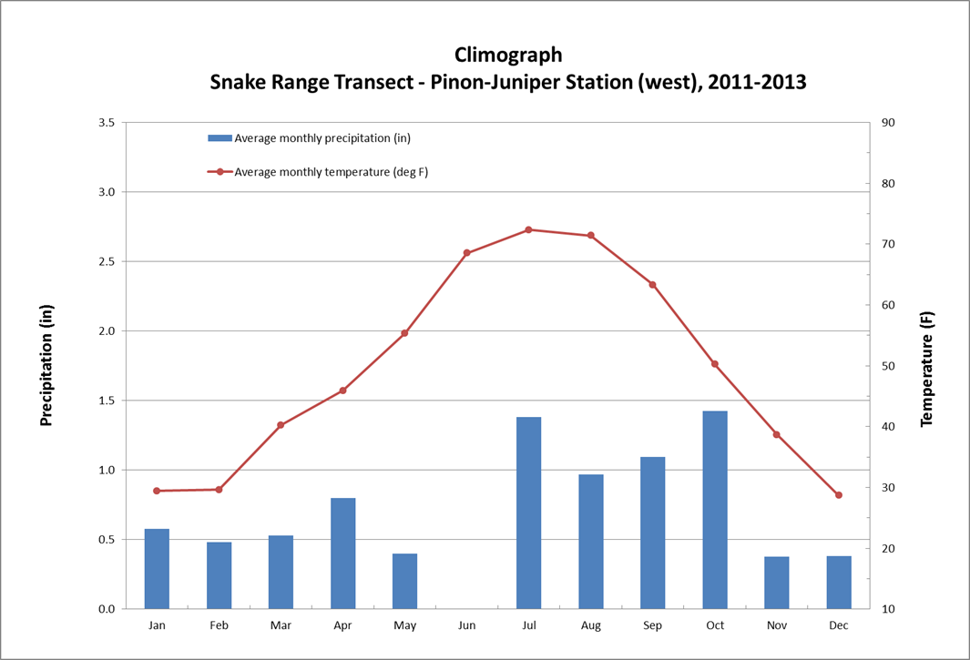

**Figure 6.**

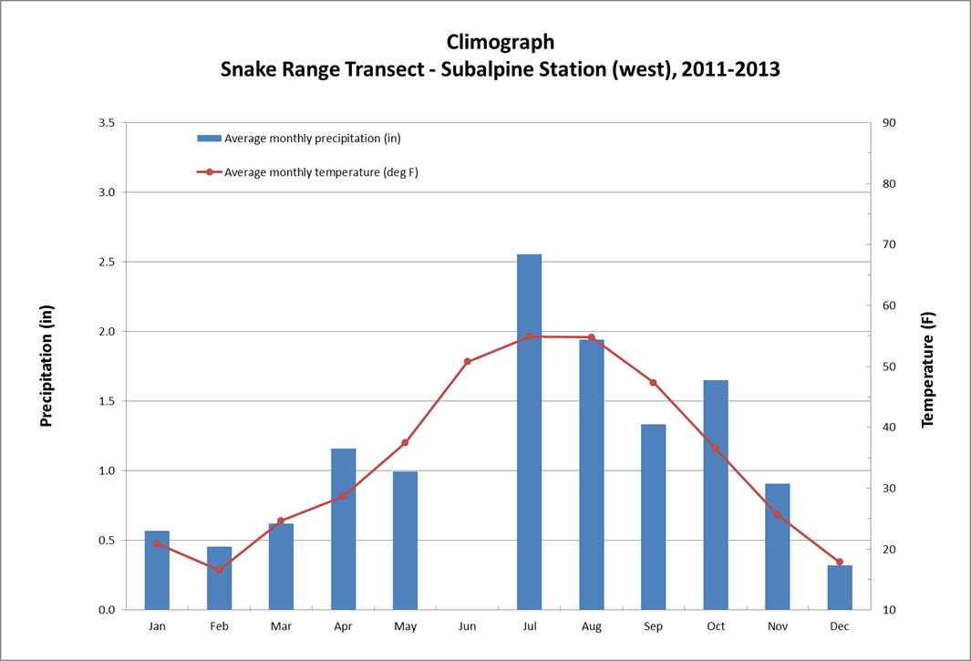

**Figure 7.**

**Figures 8-14.** Climographs based on data from the Daymet model of Daily Surface Weather and Climatological Summaries (<http://daymet.ornl.gov/custom_home>). The Daymet model was applied to the transect locations from part 1 of this investigation to create a set of precipitation and temperature data that extends from 1980 to 2012 for each transect site. Compare these graphs to figures 1-7 when you answer the questions for part 2 of this investigation.

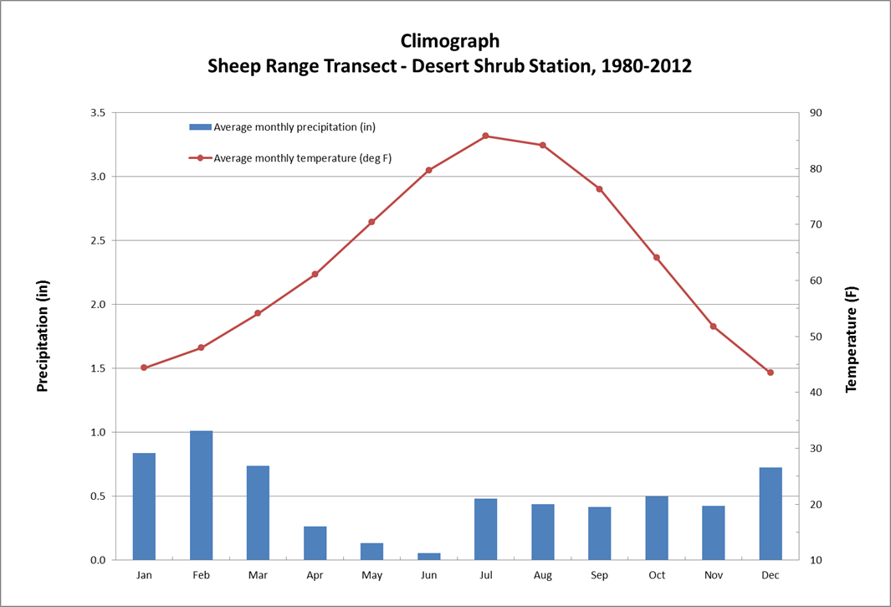

**Figure 8.**

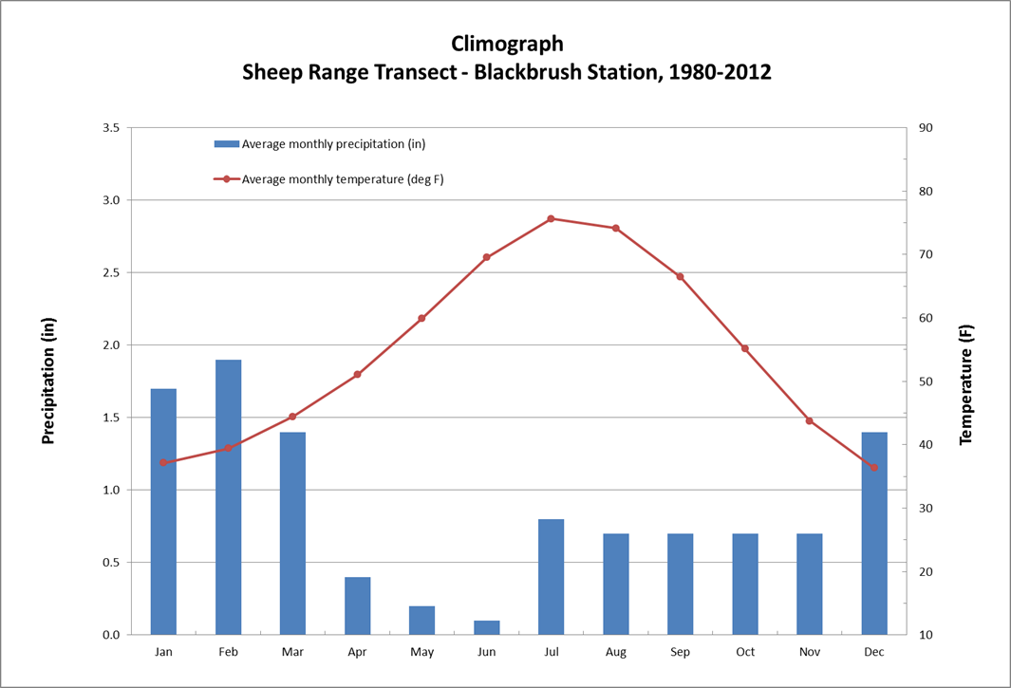

**Figure 9.**

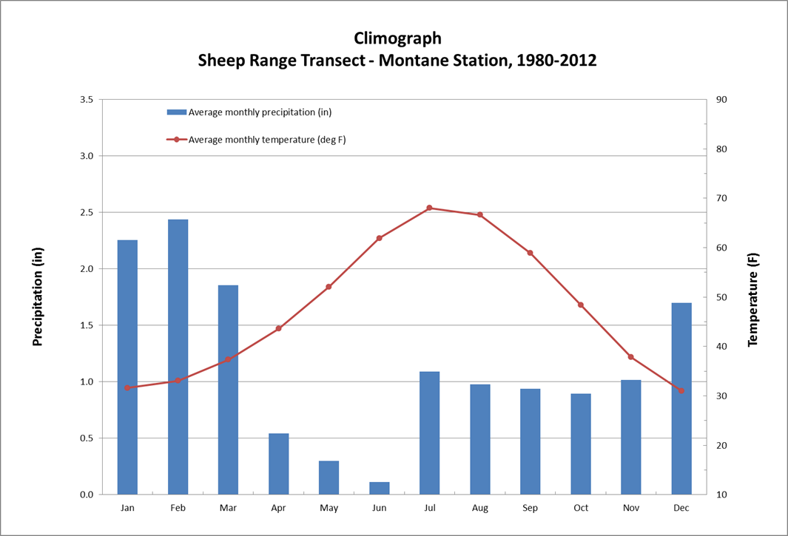

**Figure 10.**

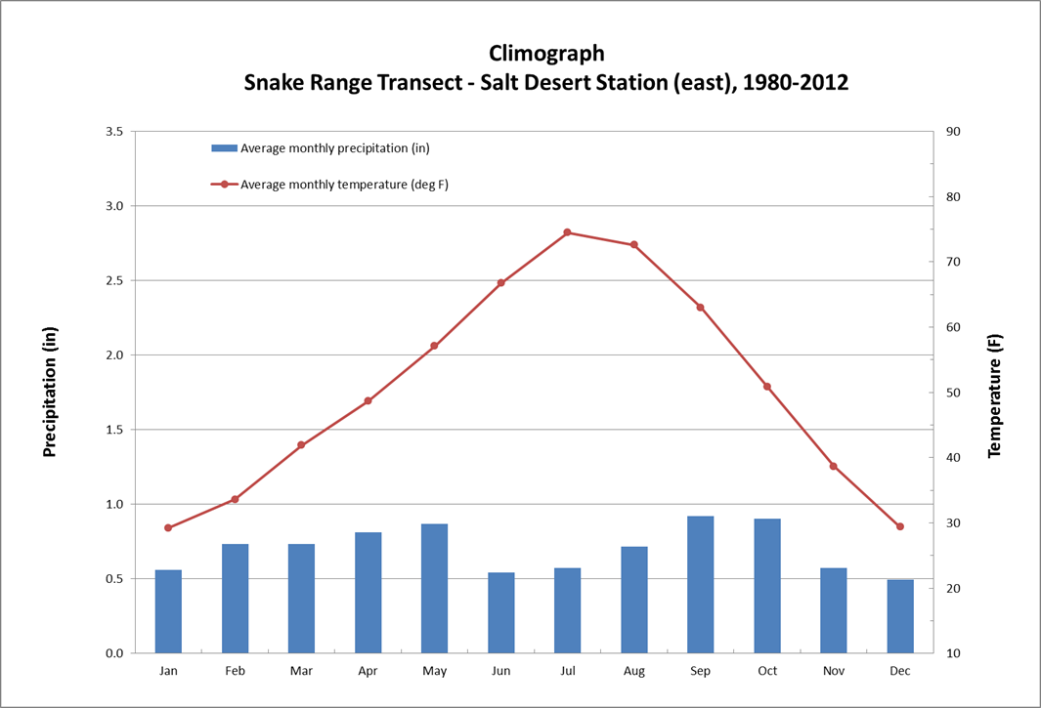

**Figure 11.**

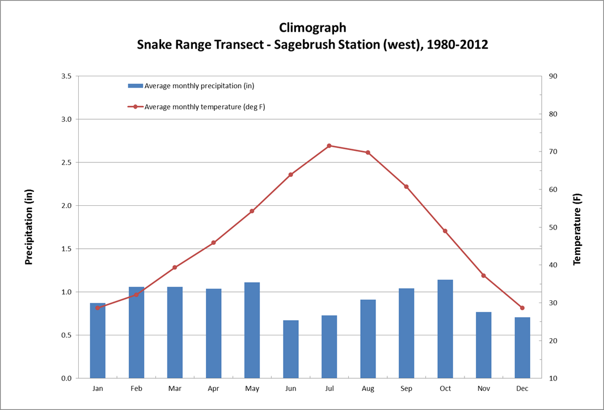

**Figure 12.**

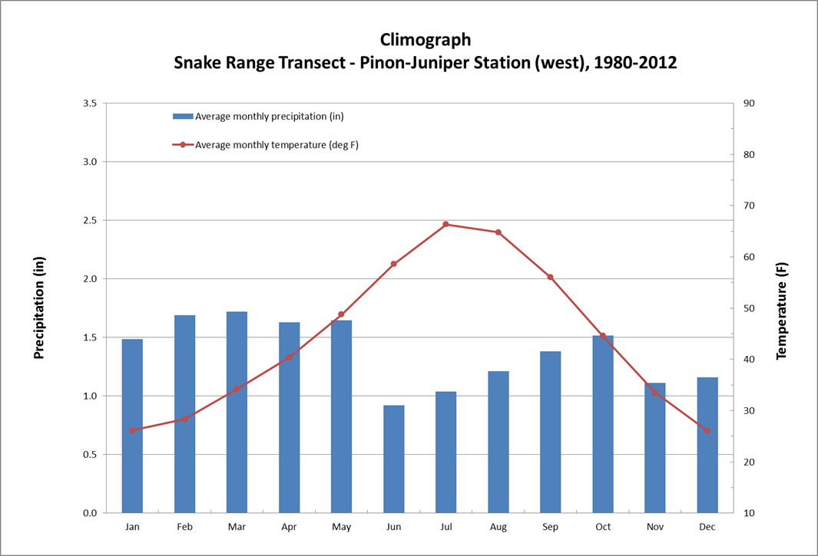

**Figure 13.**

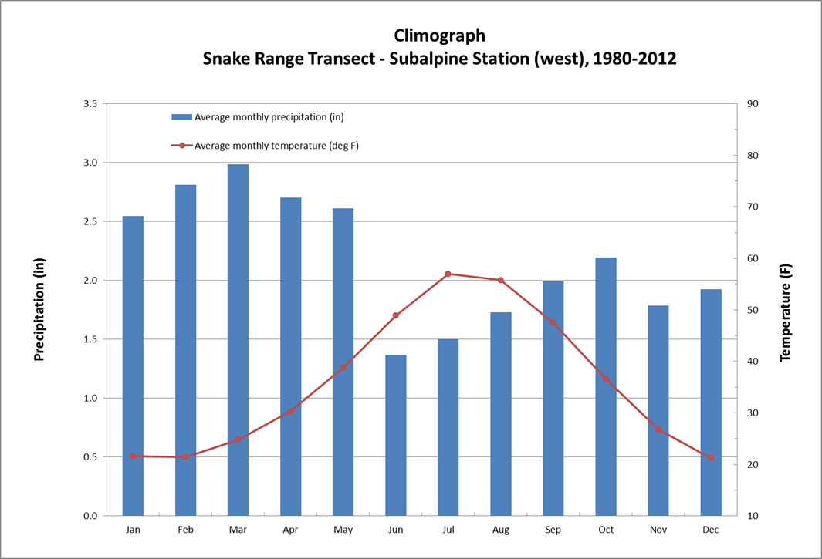

**Figure 14.**

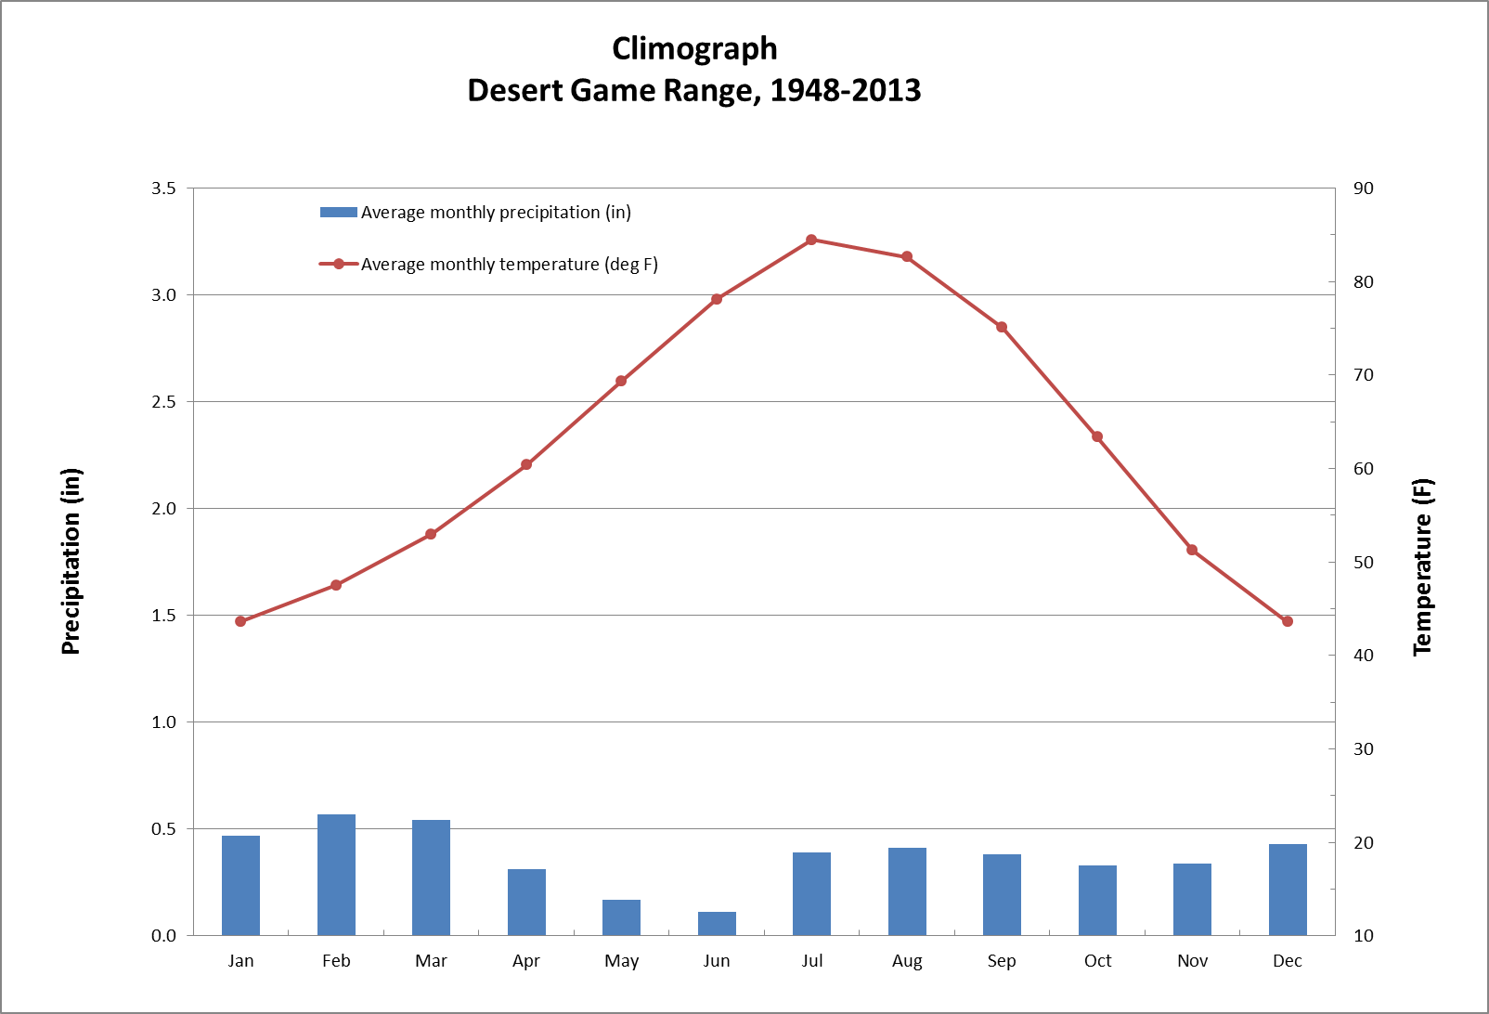

**Figure 15.** Climograph of the Desert Game Range from 1948 to 2013. The Desert Game Range is now called the Desert National Wildlife Refuge and this weather station is located on the western edge of the Sheep Range in Corn Creek (Nevada). The weather station where this data was recorded is part of the National Weather Service’s Cooperative Observer Program (COOP) and is located about 0.5 kilometers (~0.3 miles) northwest of the Sheep Range Desert Shrub Transect Station, which is shown in figures 1 and 8.